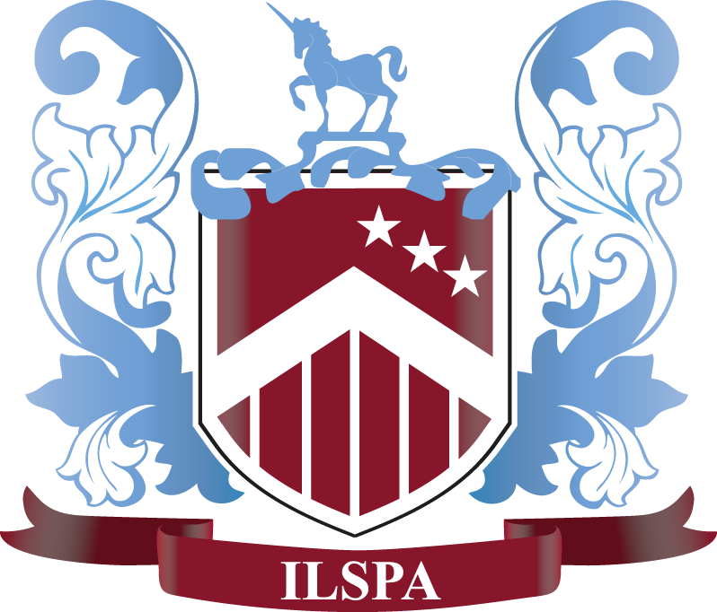

THE INSTITUTE OF LEGAL SECRETARIES AND PAs
Blacklers, Park Road, Dartington Hall, Totnes, Devon, TQ9 6EQ
Main Reception: 0207 1009210 Email: info@institutelegalsecretaries.com

ILSPA’s Continuing Professional Development Programme

CPD Programme Application

Our CPD programme is designed to support and recognise your progression within your career. Members are
encouraged to pursue continuing professional development to enhance their professional skills. Continuing
professional development will improve your knowledge and skills and, therefore, the quality of your work.

CPD can consist of many different areas and we have listed some examples of the type of continuing professional
development that will qualify:

- Studying a course (either class attendance or distance learning)
- Attending a workshop or seminar
- Writing an article for ILSPA’s Legal Secretary Journal or for another career-related magazine
- Self-study, such as reading books relevant to your career

Please note that we will only accept the Legal Secretaries Diploma course as CPD if you are presently working as
a Legal Secretary or PA.

Members of the Institute can apply for a Continuing Professional Development Certificate at any time.
You need to show that you have undertaken CPD in the past year for a minimum period of 12 hours.

Complete this form and email it to us at info@institutelegalsecretaries.com.

Personal Details
Mr/Mrs/Miss/Ms | First Name: | Surname:
e-mail:
Tel No.: |  | D.O.B:
Address:
 |  | Post Code:
Employer:
Job Position:

Type of CPD |  |  | Date and hours

I enclose details of the professional development undertaken in the past year and details of the hours spent in respect
thereof. I confirm that all the details are true and accurate.

Date: .............................................................

